PROJECT REPORT 4

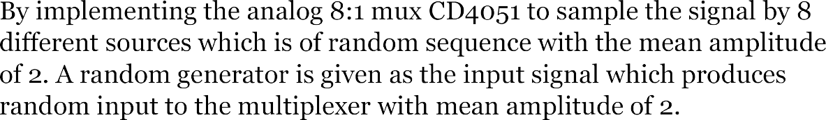





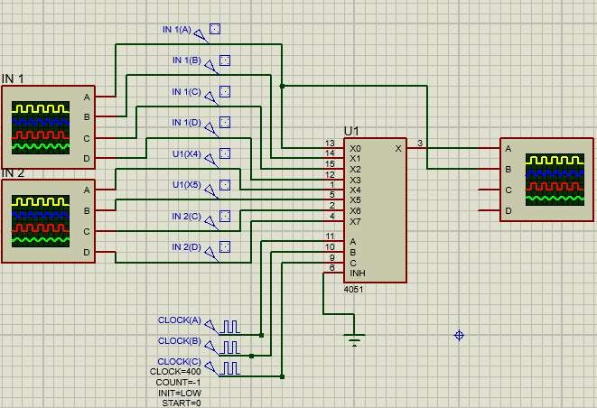

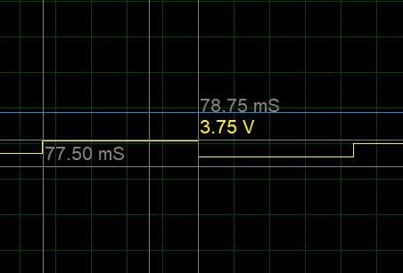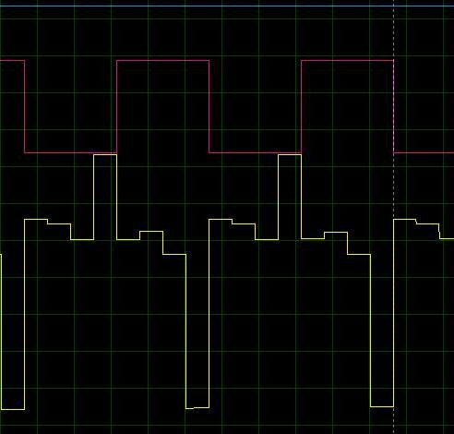

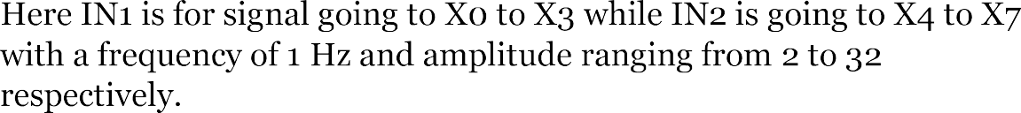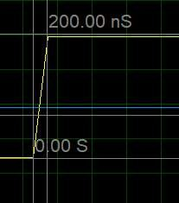





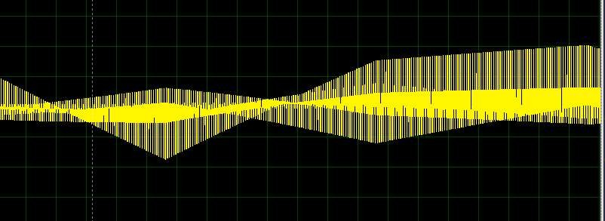

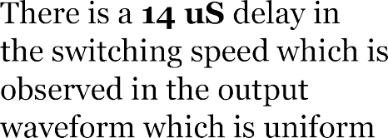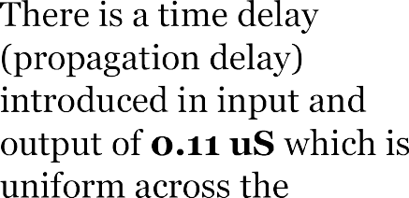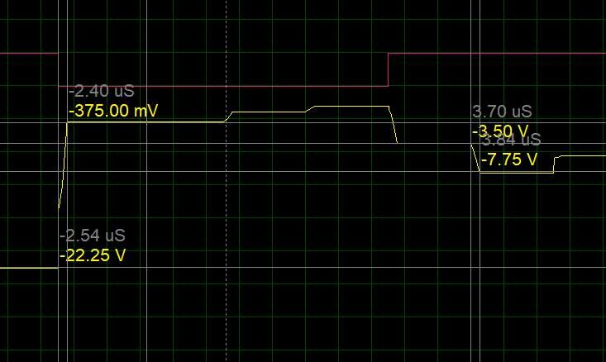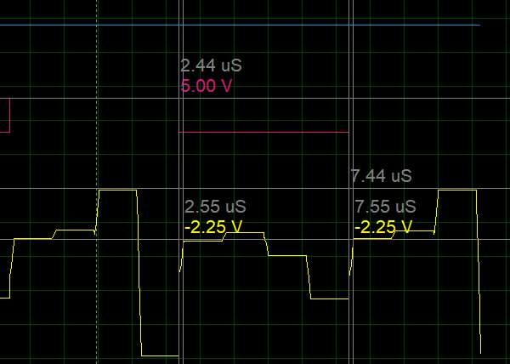

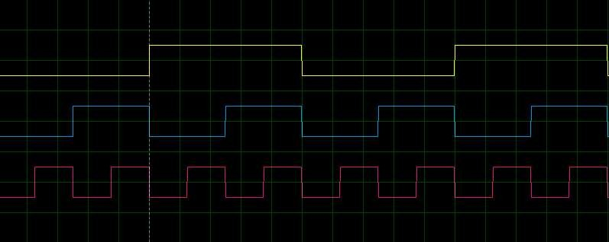

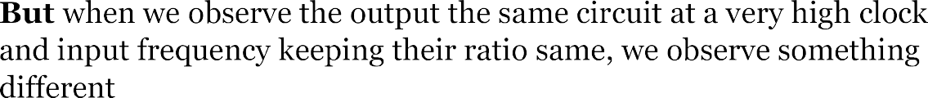



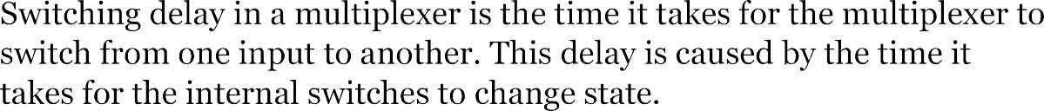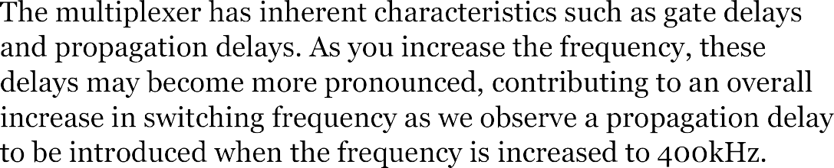



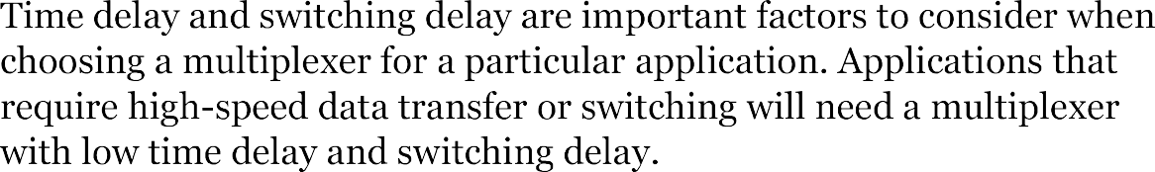

Regarding the Delay it is observed that on manual or low frequency there is no propagation delay but a very small switching delay between states.

But when the frequency of the said inputs is increased proportionally, we observe a propagation delay coherent to all the waveforms that is when the positive edge is triggered in the clock the output is sampled a few microseconds after that not at that very instant.

The switching delay is increased and becomes more prominent which could be one of the potential reasons for the presence of propagation delay in the circuit of such a scenario.